**Using defaults to encourage purchasing of sustainable and more costly clothing.**

Department of Psychology, University of Bath

XX50221 Psychological and Economic Perspectives into Decision-Making

Janina Hoffmann, Maria Cubel

January, 2023

**Abstract**

The fashion industry is responsible for 10% of global carbon emissions and is under pressure to reduce its carbon emissions (Yang et al., 2017). Choice architects have successfully utilised tools from behavioural economics to encourage sustainable behaviour. However, this has yet to be applied to encourage the sustainable consumption of fashion. Defaults are one tool used to influence decision-making; it involves presenting individuals with a pre-selected choice when decision-making. This default increases the likelihood of individuals choosing that option. This research aims to add to the minimal literature applying defaults to sustainable fashion by questioning whether defaults can increase actual sales of clothes made from more expensive sustainable fabric. The research is a field experiment in collaboration with the brand ASOS and a collection of garments that can be made from either an expensive sustainable fabric or a cheap non-sustainable fabric. Over three weeks, customers will be presented with either the sustainable fabric or the non-sustainable fabric pre-selected. The study will also have an active choice condition with no default present. A chi-squared analysis will be conducted to analyse whether the defaults influence customers' purchasing of the sustainable option. As defaults tend to have a robust effect (Jachimowicz et al., 2019), I hypothesises that when the sustainable option is pre-selected, there will be higher sales of the sustainable option. This research adds to the literature investigating sustainable behaviours, as it is one of the first to analyse the effectiveness of defaults on expensive sustainable goods, and it advances the one current study applying defaults to sustainable fashion. If the defaults increase sales of sustainable garments, this demonstrates that defaults on sustainable options could become an industry standard to improve demand for sustainable clothes, which is a small step in improving the industry's carbon footprint.

**Introduction**

The fashion industry has one of the largest carbon footprints; it is responsible for 10% of global carbon dioxide emissions, more than the aviation and shipping industries combined (Sanders, 2019). The industry has three main routes to reducing carbon emissions: supply, demand, and government regulations; however, this research focuses on demand by investigating consumer decision-making for sustainable goods.

Sustainable fashion refers to garments produced with care for labour and the environment (Hacking & Guthrie, 2008). There has been growing interest in sustainable fashion, as one-third of consumers prefer to buy from sustainable brands (Unilever, 2017). However, there is a “green gap” as consumer intentions do not align with actual behaviour (Kangasniemi, 2022). Contrary to traditional economic theory, when making decisions associated with the environment, people may fail to consider all related externalities (Burritt, 2004). For example, high cost may deter people from sustainable clothing; however, positive externalities such as ethical practices and lower emissions are ignored. Therefore, choice architecture is a valuable approach to encourage sustainable purchasing. I chose to investigate defaults as they are a widely used tool, easy to implement, and effective on a large scale (Hale, 2018). Therefore, they have potential to make meaningful changes in the consumption of sustainable clothes (Brown & Krishna, 2004). A default is a pre-selected choice presented during decision-making, rendering people more likely to select that option by 0.65 standard deviations (Jachimowicz et al., 2019).

Defaults have successfully encouraged sustainable behaviours such as increasing vegetarian and organic foods and reducing water consumption (Hansen et al., 2019; Kuhn et al., 2020; Frederiks et al., 2015). However, research into sustainable fashion is in early stages, and there are gaps in the literature. Firstly, many studies make generalisations about sustainable consumption by investigating attitudes and intentions; however, they fail to study real decision-making (Song & Ko, 2017; Kaur & Bhardwaj, 2021). Additionally, current research into defaults is yet to investigate the effect of defaults on more expensive items. This is especially significant when understanding fashion, as cost is an important barrier to purchasing sustainable clothing (Read, 2017). However, the rise of organic foods since the early 2000s demonstrates the potential for other sustainable goods, such as fashion garments, to become popular despite their higher cost (AMI, 2022).

Currently, there is one laboratory experiment investigating the effect of defaults in sustainable E-commerce purchasing decisions; however, this research did not find that defaults increase the sales of sustainable clothes (Mirbabaie et al., 2021). Mirbabaie explained that the defaults failed as participants “backfired’ after being presented with excessive nudges and defaults. The proposed study will differ from Mirbibaie’s as it is a real-world study and only uses one default. Additionally, my design encourages trust between the consumer and the brand to mitigate the likelihood of the backfire effect.

The study draws inspiration from research that successfully increased purchasing of organic food online (Kuhn et al., 2020; Coffino et al., 2020). I expect to see similar results when investigating sustainable garments; however, there are some important differences, such as the price difference between food items being much smaller than sustainable garments (£1 difference compared to £49). Additionally, there may be differences in how people make decisions about food and clothing goods.

The research question is, “Are defaults successful in increasing sales of sustainable and more costly clothing?” I hypothesise that pre-selection of the sustainable fabric will increase sales of the sustainable option as defaults tend to have a robust effect (Jachimowicz et al., 2019). Adding to research into sustainability, this is one of the first studies analysing the effectiveness of defaults on expensive sustainable goods and advances on the current study applying defaults to sustainable fashion.

**Method**

This study is a between-subjects real-world study of consumers purchasing sustainable clothing online. In collaboration with the brand ASOS (www.asos.com), every garment in one of their collections will have the option of two different fabrics, one sustainable and one non-sustainable. The garments are genderless and size-inclusive, not to rule out any customers. The study draws inspiration from the sustainable brand AYM (www.aym-studio.com), which provides customers with two options of sustainable fabrics. The study will analyse the number of sustainable options purchased during the experiment under three conditions.

The website interface (See Figure 1) will present the option for each garment to be made with a more expensive sustainable fabric (£69) and a cheaper non-sustainable fabric (£20). There will be an explanation of the fabric options and each fabric’s impact on the environment (See Appendix A). The explanation provides transparency for customers, which should improve default effectiveness as customers trust that the default is used to benefit consumer free will and the environment (Tannenbaum et al., 2017). Participants will choose the fabric type when purchasing a garment by clicking the option which highlights it in black (See Figure 2).

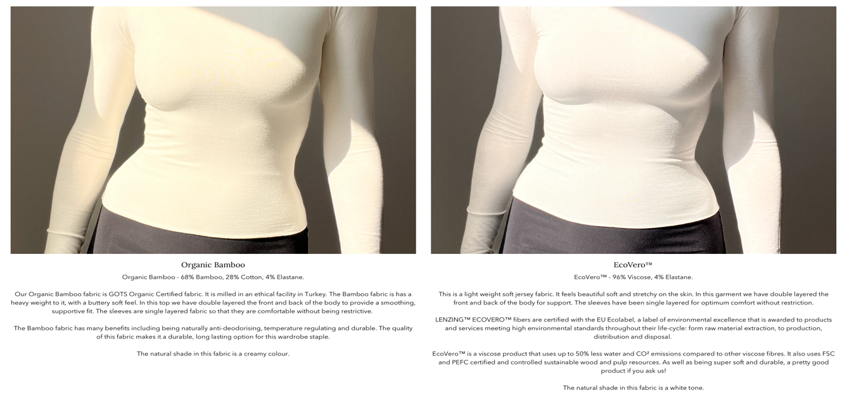

Organic Bamboo - 68% Bamboo, 28% Cotton, 4% Elastane.  
  
Our Organic Bamboo fabric is GOTS Organic Certified fabric. It is milled in an ethical facility in Turkey. The Bamboo fabric is has a heavy weight to it, with a buttery soft feel. In this top we have double layered the front and back of the body to provide a smoothing, supportive fit. The sleeves are single layered fabric so that they are comfortable without being restrictive.   
  
The Bamboo fabric has many benefits including being naturally anti-deodorising, temperature regulating and durable. The quality of this fabric makes it a durable, long lasting option for this wardrobe staple.  
  
The natural shade in this fabric is a creamy colour.

Bamboo is often considered a more sustainable option than cotton because it is a fast-growing and renewable resource. Bamboo also requires less water to grow than cotton and can be grown without the use of pesticides or fertilizers.

Cotton - Cotton 60%, Polyester 40%

Our Organic Cotton fabric is GOTS Organic Certified. It is made from high-quality cotton and is milled in an ethical facility.   
  
This is a lightweight soft jersey fabric. It feels beautiful soft and stretchy on the skin. In this garment we have double layered the front and back of the body for support. The sleeves have been single layered for optimum comfort without restriction.

The natural shade in this fabric is a tan tone.

Cotton is not necessarily an unsustainable fabric for clothing, but the way it is grown and produced can have a negative impact on the environment. Conventional cotton is often grown using large amounts of pesticides and fertilizers, which can lead to pollution and soil degradation. Additionally, cotton is a water-intensive crop, which can lead to water scarcity in regions where it is grown.

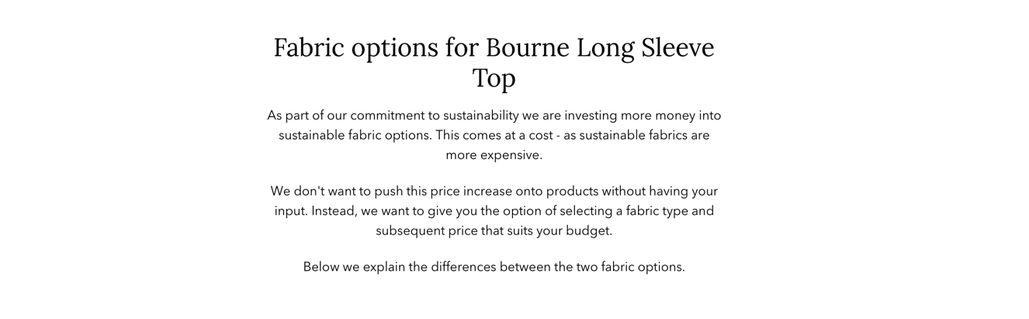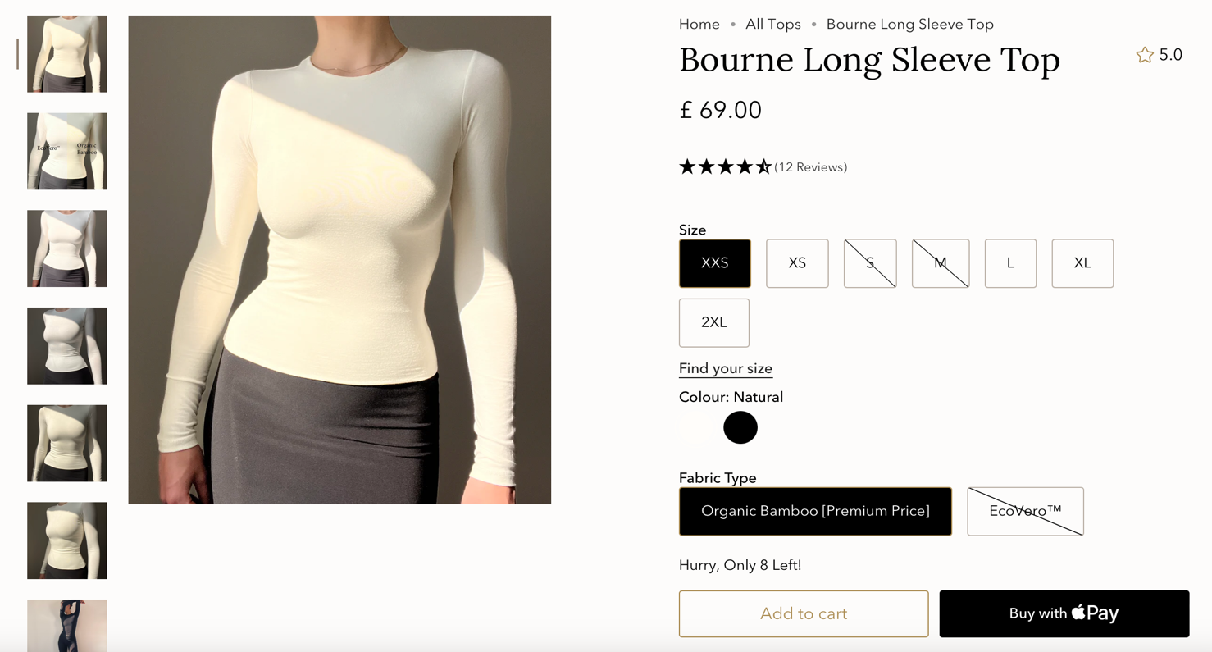

Cotton

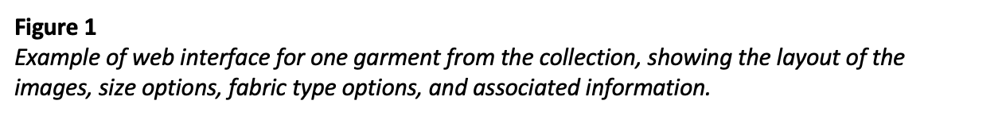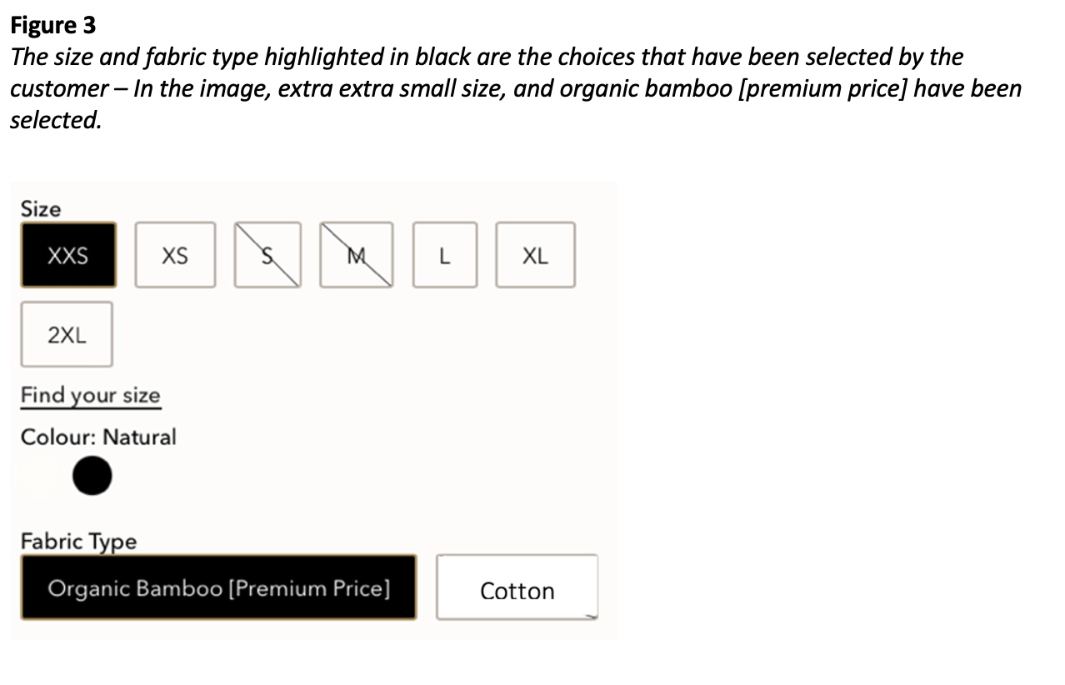

**Procedure**

The number of sustainable garments purchased will be analysed in three conditions, opt-in, opt-out, and active choice.

In the opt-in condition (explicit-consent framing), the non-sustainable option (cotton) will be pre-selected, (see Figure 4). The customer can opt-in by clicking the more sustainable option (organic bamboo), and the price will change to reflect the higher cost (see Figure 5).

In the opt-out condition (assumed-consent framing), the sustainable option will be pre-selected (See Figure 5). The customer can opt-out by clicking the non-sustainable option, and the price will change to reflect the lower cost (see Figure 5).

In the active choice condition, there will be no default option, and participants must click on the fabric to confirm their choice (See Figure 6). The price will not be shown until they select an option. The active choice condition determines whether the results of the defaults simply reflect fabric or price preferences.

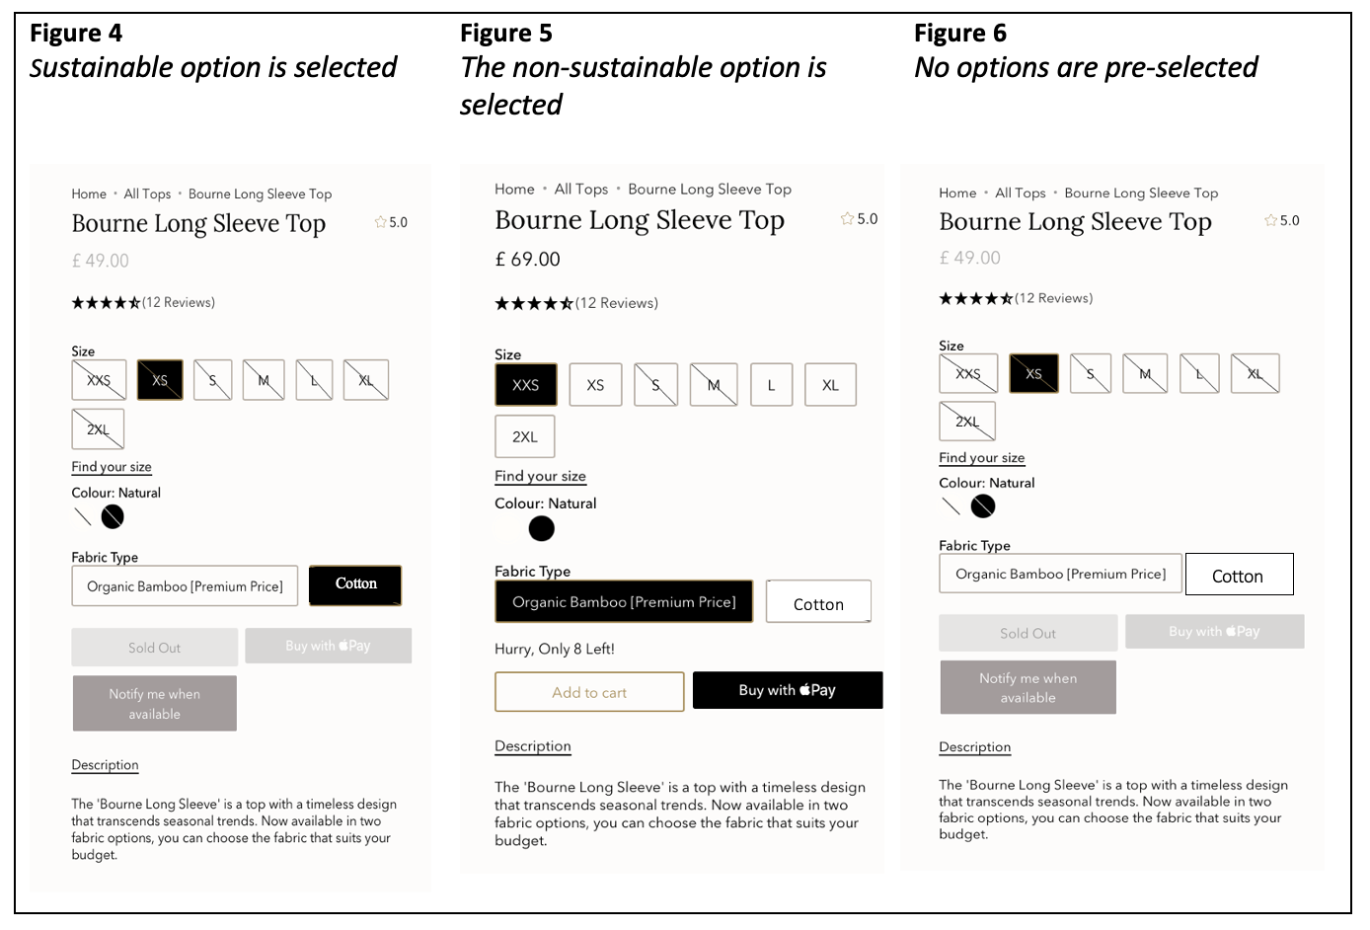

£20.00

**Sample size**

The conditions and correlated responses will be collected and recorded over three weeks in April 2023, as this is a high-traffic month with no promotional sales (Statista, 2022). Each week, the website will present a different condition. Customers may wait between viewing an item and purchasing it; therefore, this timeframe mitigates the problem that consumers view a product one day and are presented with a different default when they purchase it (Kukar-Kinney & Close, 2009). This timeframe should allow for at least 300 sales, which similar to the organic food research that has 200 to 400 participants (Kuhn et al., 2020) and three-week designs; one baseline and two experimental weeks (Panzone et al., 2021). However, there is no exact planned sample size to achieve a specific power since this depends on the sales obtained.

**Statistical analysis**

The independent variable is the framing presented, and the dependent variable is the number of sustainable clothes purchased. A chi-Squared and effect size analysis will analyse whether the proportion of sustainable fabric options bought differs significantly for the three conditions. This aligns with other research of choice architecture tools that compare treatment groups using chi-squared (Cosic et al., 2018).

**Expected results**

Despite contradicting research (Mirbabaie et al., 2021), I anticipate that when the sustainable option is the default, sales for this option will be higher compared to the active choice and non-sustainable default conditions. I anticipate this as substantial evidence supports the robust effects of defaults (Van Gestel et al., 2021; Ingendahl et al., 2020). However, I expect less effect than the average default (average effect size 21%) as the higher price may deter customers (Hummel & Maedche, 2019; Brown & Krishna, 2004). If the findings are significant, defaults may be a valuable tool to encourage sustainable consumption, even when products are expensive. Alternatively, if the results are insignificant, the research would help define the boundaries of default effectiveness.

**Discussion**

This study contributes to literature encouraging the engagement of voluntary behaviours that benefit society. If our study yields significant results, then there are many implications. Firstly, the literature adds to the minimal research on defaults and sustainable fashion. Although the research only partially fills the gap, it provides a valuable perspective into real customer behaviour since the other study is conducted in a lab. Additionally, this research resolves some issues with the previous, simplifying the study and settling trust issues for the customer. The real-world study accurately represents consumer behaviour as customers use their own money and are unaware that they are being studied.

Although sustainable clothing is not the complete solution to reduce the fashion industry’s impact on climate change, if defaults increase sales of sustainable garments, this shows potential that sustainable fashion could become a norm and that defaults could become an industry standard to improve demand of sustainable options. On a larger scale, this demand will force brands to behave sustainably to attract consumers. This could be a small step improving the industry's carbon footprint.

If the hypothesis is significant, there are several explanations. Firstly, customers may perceive the default as an endorsement by a trusted brand (McKenzie et al., 2006). Alternatively, instead of considering the two fabric options, the default may cause customers to consider only that option (Johnson et al., 2012). Lastly, there is a considerable difference in behaviour for both contexts. In the opt-out frame choosing the sustainable fabric involves no action, however, in the opt-out frame, consumers must express an explicit interest in paying for the more expensive fabric.

This research has some limitations. Firstly, default framing is only one tool from choice architecture. It may be helpful to compare the impact of other tools, such as social norms, on sustainable clothing consumption. Additionally, the results may be influenced by the brand in collaboration. As ASOS is a fast fashion brand, the customer demographic is not necessarily environmentally conscious. However, as the first real-world study, this approach is practical, as it assesses the general public's views. However, future research could conduct research with AYM, where the customers are environmentally conscious, to analyse any differences.

If the results are insignificant, a follow-up study investigating explanations of consumers' decision-making could identify factors which may be a significant influence, such as fabric colours, budget, or the cost-of-living crisis. A future laboratory experiment could change the prices of the two fabrics, or the current study could be replicated during a sale to see whether the default is more successful when prices are lower. Investigating these could help understand the boundaries of default effectiveness.

**Appendix A:**

**Table 1.**

*The information provided on the website about the two m*aterial options

|  |  |  |
| --- | --- | --- |
| Material | Information given | Cost |
| Organic Bamboo  [Premium Price] | Organic Bamboo - 68% Bamboo, 28% Cotton, 4% Elastane.  Our Organic Bamboo fabric is GOTS Organic Certified fabric. It is milled in an ethical facility in Turkey. The Bamboo fabric is has a heavy weight to it, with a buttery soft feel. In this top we have double layered the front and back of the body to provide a smoothing, supportive fit. The sleeves are single layered fabric so that they are comfortable without being restrictive.   The Bamboo fabric has many benefits including being naturally anti-deodorising, temperature regulating and durable. The quality of this fabric makes it a durable, long lasting option for this wardrobe staple.  The natural shade in this fabric is a creamy colour.  Bamboo is often considered a more sustainable option than cotton because it is a fast-growing and renewable resource. Bamboo also requires less water to grow than cotton and can be grown without the use of pesticides or fertilizers. | £69 |
| Normal | Shell: Cotton 60%, Polyester 40%  Our Organic Cotton fabric is GOTS Organic Certified. It is made from high-quality cotton and is milled in an ethical facility.   This is a lightweight soft jersey fabric. It feels beautiful soft and stretchy on the skin. In this garment we have double layered the front and back of the body for support. The sleeves have been single layered for optimum comfort without restriction.  The natural shade in this fabric is a tan tone.  Cotton is not necessarily an unsustainable fabric for clothing, but the way it is grown and produced can have a negative impact on the environment. Conventional cotton is often grown using large amounts of pesticides and fertilizers, which can lead to pollution and soil degradation. Additionally, cotton is a water-intensive crop, which can lead to water scarcity in regions where it is grown. | £20 |

The price of the sustainable garment was taken from AYM, a site that produce a long sleeve white top made from this material for £69. The price for the non-sustainable garment was taken from an equivalent non-sustainable option found on the ASOS website.

References

AMI. (2022). *Europe: retail sales of organic products by country 2019*. Statista. https://www.statista.com/statistics/632751/retail-sales-of-organic-products-europe/

Anzman‐Frasca, S., McGovern, L., Ferrante, M. J., Drozdowsky, J., Epstein, L. H., Hollis‐Hansen, K., Lassetter, L., Leone, L. A., & Tan, S. (2022). Effects of a grocery shopping intervention designed to improve diet adherence in diabetes: a randomized trial. *Obesity*, *31*(1), 62–73. https://doi.org/10.1002/oby.23588

Barbarossa, C., & Pastore, A. (2015). Why environmentally conscious consumers do not purchase green products. *Qualitative Market Research: An International Journal*, *18*(2), 188–209. https://doi.org/10.1108/qmr-06-2012-0030

Brown, Christina L., & Krishna, A. (2004). The skeptical shopper: A metacognitive account for the effects of default options on choice. *Journal of Consumer Research*, *31*(3), 529–539. https://doi.org/10.1086/425087

Chan, T., & Wong, C. W. Y. (2012). The consumption side of sustainable fashion supply chain. *Journal of Fashion Marketing and Management: An International Journal*, *16*(2), 193–215. https://doi.org/10.1108/13612021211222824

Coffino, J. A., Udo, T., & Hormes, J. M. (2020). Nudging while online grocery shopping: A randomized feasibility trial to enhance nutrition in individuals with food insecurity. *Appetite*, *152*, 104714. https://doi.org/10.1016/j.appet.2020.104714

Cosic, A., Cosic, H., & Ille, S. (2018). Can nudges affect students’ green behaviour? A field experiment. *Journal of Behavioral Economics for Policy*, *2*(1), 107–111. https://sabeconomics.org/wordpress/wp-content/uploads/JBEP-2-1-15.pdf

Dolan, P., Hallsworth, M., Halpern, D., King, D., Metcalfe, R., & Vlaev, I. (2012). Influencing behaviour: The mindspace way. *Journal of Economic Psychology*, *33*(1), 264–277. https://doi.org/10.1016/j.joep.2011.10.009

Frederiks, E. R., Stenner, K., & Hobman, E. V. (2015). Household energy use: Applying behavioural economics to understand consumer decision-making and behaviour. *Renewable and Sustainable Energy Reviews*, *41*, 1385–1394. https://doi.org/10.1016/j.rser.2014.09.026

Goworek, H., Fisher, T., Cooper, T., Woodward, S., & Hiller, A. (2012). The sustainable clothing market: An evaluation of potential strategies for UK retailers. *International Journal of Retail & Distribution Management*, *40*(12), 935–955. https://doi.org/10.1108/09590551211274937

Grebitus, C., Steiner, B., & Veeman, M. M. (2016). Paying for sustainability: A cross-cultural analysis of consumers’ valuations of food and non-food products labeled for carbon and water footprints. *Journal of Behavioral and Experimental Economics*, *63*, 50–58. https://doi.org/10.1016/j.socec.2016.05.003

Hacking, T., & Guthrie, P. (2008). A framework for clarifying the meaning of Triple Bottom-Line, integrated, and sustainability assessment. *Environmental Impact Assessment Review*, *28*(2-3), 73–89. https://doi.org/10.1016/j.eiar.2007.03.002

Hale, L. A. (2018). At home with sustainability: From green default rules to sustainable consumption. *Sustainability*, *10*(1), 249. https://doi.org/10.3390/su10010249

Hansen, P. G., Schilling, M., & Malthesen, M. S. (2019). Nudging healthy and sustainable food choices: three randomized controlled field experiments using a vegetarian lunch-default as a normative signal. *Journal of Public Health*, *43*(2). https://doi.org/10.1093/pubmed/fdz154

Hummel, D., & Maedche, A. (2019, March). *How effective is nudging? A quantitative review on the effect sizes and limits of empirical nudging studies*. ResearchGate; unknown. https://www.researchgate.net/publication/331704698_How_Effective_Is_Nudging_A_Quantitative_Review_on_the_Effect_Sizes_and_Limits_of_Empirical_Nudging_Studies

Ingendahl, M., Hummel, D., Maedche, A., & Vogel, T. (2020). Who can be nudged? Examining nudging effectiveness in the context of need for cognition and need for uniqueness. *Journal of Consumer Behaviour*, *20*(2). https://doi.org/10.1002/cb.1861

Jachimowicz, J. M., Duncan, S., Weber, E., & Johnson, E. (2019). When and why defaults influence decisions: A meta-analysis of default effects. *Behavioural Public Policy*, *3*(02), 159–186. https://doi.org/10.1017/bpp.2018.43

Johnson, E. J., & Goldstein, D. (2003). Do defaults save lives? *Science*, *302*(5649), 1338–1339. https://doi.org/10.1126/science.1091721

Kangasniemi, S. (2022). Do consumers’ attitudes toward sustainability play a significant role in the decision-making process behind fashion purchases? Exploring the attitude-behaviour gap in 2022. *Aaltodoc.aalto.fi*. https://aaltodoc.aalto.fi/handle/123456789/114259

Kaur, J., & Bhardwaj, N. (2021). Their control will make or break the sustainable clothing deal: A study of the moderating impact of actual behavioural control on the purchase intention-behaviour gap for sustainable clothing in india. *Australasian Business, Accounting and Finance Journal*, *15*(5), 82–98. https://doi.org/10.14453/aabfj.v15i5.6

Kenward, A. (2010). *Awash in awareness: Knowing a product’s “water footprint” may help consumers conserve H2O*. Scientific American. http://www.scientificamerican.com/article/water-footprint/

Kuhn, S., Ihmels, M., & Kutzner, F. (2020). Organic defaults in online‐shopping: Immediate effects but no spillover to similar choices. *Journal of Consumer Behaviour*. https://doi.org/10.1002/cb.1850

Kukar-Kinney, M., & Close, A. G. (2009). The determinants of consumers’ online shopping cart abandonment. *Journal of the Academy of Marketing Science*, *38*(2), 240–250. https://doi.org/10.1007/s11747-009-0141-5

Magnusson, M. K., Arvola, A., Koivisto Hursti, U., Åberg, L., & Sjödén, P. (2001). Attitudes towards organic foods among Swedish consumers. *British Food Journal*, *103*(3), 209–227. https://doi.org/10.1108/00070700110386755

McKenzie, C. R. M., Liersch, M. J., & Finkelstein, S. R. (2006). Recommendations implicit in policy defaults. *Psychological Science*, *17*(5), 414–420. https://doi.org/10.1111/j.1467-9280.2006.01721.x

McNeill, L., & Moore, R. (2015). Sustainable fashion consumption and the fast fashion conundrum: Fashionable consumers and attitudes to sustainability in clothing choice. *International Journal of Consumer Studies*, *39*(3), 212–222.

Mirbabaie, M., Marx, J., & Germies, J. (2021). Conscious commerce -digital nudging and sustainable e-commerce purchase decisions. *Australasian Conference on Information Systems*. https://arxiv.org/pdf/2202.08696.pdf

Moshinsky, A., & Bar-Hillel, M. (2010). Loss aversion and status quo label bias. *Social Cognition*, *28*(2), 191–204. https://doi.org/10.1521/soco.2010.28.2.191

Panzone, L., Ulph, A., Hilton, D., Gortemaker, I., & Tajudeen, I. (2021). Sustainable by design: Choice architecture and the carbon footprint of grocery shopping. *Journal of Public Policy & Marketing*, 074391562110088. https://doi.org/10.1177/07439156211008898

Pichert, D., & Katsikopoulos, K. V. (2008). Green defaults: Information presentation and pro-environmental behaviour. *Journal of Environmental Psychology*, *28*(1), 63–73. https://doi.org/10.1016/j.jenvp.2007.09.004

Read, J. (2017). Overcoming barriers to ethical clothing consumption: a conjoint analysis approach. In *ir.canterbury.ac.nz*. https://doi.org/10.26021/5516

Sanders, L. (2019). *The 2019 Ethical Fashion Report: THE TRUTH BEHIND THE BARCODE*. https://media.business-humanrights.org/media/documents/files/documents/FashionReport_2019_9-April-19-FINAL.pdf

Song, S., & Ko, E. (2017). Perceptions, attitudes, and behaviors toward sustainable fashion: Application of Q and Q-R methodologies. *International Journal of Consumer Studies*, *41*(3), 264–273. https://doi.org/10.1111/ijcs.12335

Statista. (2022). *UK internet retail: monthly sales value 2016-2022 | Statista*. Statista; Statista. https://www.statista.com/statistics/380070/uk-internet-retail-monthly-sales-value/

Tannenbaum, D., Fox, C. R., & Rogers, T. (2017). On the misplaced politics of behavioural policy interventions. *Nature Human Behaviour*, *1*(7). https://doi.org/10.1038/s41562-017-0130

Taube, O., & Vetter, M. (2019). How green defaults promote environmentally friendly decisions: Attitude‐conditional default acceptance but attitude‐unconditional effects on actual choices. *Journal of Applied Social Psychology*, *49*(11), 721–732. https://doi.org/10.1111/jasp.12629

Unilever. (2017). Report shows a third of consumers prefer sustainable brands. In *Unilever*. www.unilever.com. https://www.unilever.com/news/press-and-media/press-releases/2017/report-shows-a-third-of-consumers-prefer-sustainable-brands/

Van Gestel, L., Adruabbse, N., & De Ridder, D. (2021). Motivated by default - How nudges facilitate people to act in line with their motivation. *Motivational Science*, *7*(3).

Witek, L., & Kuźniar, W. (2020). Green purchase behavior: The effectiveness of sociodemographic variables for explaining green purchases in emerging market. *Sustainability*, *13*(1), 209. https://doi.org/10.3390/su13010209

Zanoli, R., & Naspetti, S. (2002). Consumer motivations in the purchase of organic food. *British Food Journal*, *104*(8), 643–653. https://doi.org/10.1108/00070700210425930

Zhang, B., Zhang, Y., & Zhou, P. (2021). Consumer attitude towards sustainability of fast fashion products in the UK. *Sustainability*, *13*(4), 1–23. Mdpi. https://doi.org/10.3390/su13041646